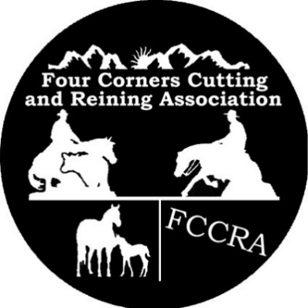
FCCRA RANCH RIDING/REINING

TECHNIQUES CLINIC
With Alex Spencer

Saturday, August 17, 2019
9 am to 4 pm
Sauls Creek Stables
3113 CR 527, Bayfield, CO

Entry Form
The undersigned Owner/Exhibitor does hereby release FCCRA, Alex Spencer, Kelly Gabbard and the Officers and Organizers of this event from any liability arising out of my participation in the same, and does hereby agree to hold harmless and indemnify such individuals from any liability, whether intentionally or negligently caused, arising out of my participation of which I am the Owner/Exhibitor and to any person injured by such horse or rider. All activities will be conducted in a safe manner, and any animal or rider deemed to be unsafe, in the dole opinion of the event management, may be barred from participation in any class or from the show.

****WARNING****
Under Colorado law, any equine activity or equine professional is not liable for an injury or the death of a participant in equine activity sponsor or equine professional is not liable for an injury or the death of a participant in equine activities resulting exclusively from the inherent risks of equine activities.

Signed: _____________________________________ Date ________________________
(Legal Guardian if under 18)

Clinic Participation Fee:

Member $50.00 $ _________ NonMember $75.00 $_________ Youth $30.00 $______

Total Paid $ ______________

Mail check to: FCCRA C/O Pat James, 1528 CR 222, Durango, CO 81303
For more information contact Pat at 970 946-8575

Rider Information:

Name: ____________________________ Contact Phone ______________________

Email ___________________________________

Address: __________________________________________________________________
Street City State Zip

If Minor, Legal Guardian _______________________ Contact Phone _________________

I am a FCCRA member:

